Every Drowning is Preventable!
To keep your family safe in, on and around water, follow these simple water-safety guidelines:
The first place to look when a child goes missing is anywhere where there might be water — swimming pools and spas — check the neighbors’ backyard too. Having multiple layers of protection can help ensure water safety and prevent drowning in a home pool or spa.
No one is drown-proof, and drowning does not discriminate.
Drowning is fast and silent. It can happen in as little as 20-60 seconds. Drowning does not always look like we would expect.
When a child goes missing: CHECK THE WATER FIRST!
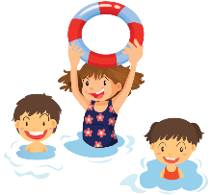
Memorial Day Weekend marks the beginning of summer and all its fun to be had. It is also the start of the most dangerous time for child drownings. Last year 2020, 80 children and teens drowned in Texas alone. So far to date, 20 plus have already drowned. (Texas Department of Family and Protective Services)
Here are some water-safety tips:
- Barriers: Fence it in. Surround your pool with a fence that’s at least 4 feet tall. Make sure kids can’t squeeze through and avoid chain-link fences which can be easy for kids to climb. Be sure to install self-closing latches and gates.
- Sound: Install alarms on doors leading to the pool area or underwater pool alarms that sound when something hits the water. Make sure you can hear the alarm inside the house.
- Empty inflatable pools after each use. Never leave any water around.
- Remove ladders or steps to above ground pools when not in use. No toys floating in pool that can draw attention to the water.
- Children should LEARN how to swim. Most children can learn to swim between the ages of 2- 5 but know that swimming lessons will not necessarily prevent a child from drowning. Don’t assume your child will use good judgement around the pool.
- All children need to be taught the RULES before the pool:
Rules Before the Pool!
- Never Ever Swim Alone
- Do not go in, near or touch the water without adult permission
- Children should not be allowed to swim on a babysitter’s watch-too much responsibility and lack of training.
- Post the rules, buy or make a sign where the swimmers know and see them
- Not running, pushing or pulling
- No glass around the pool
- No chewing gum, candy or food in the mouth when in the pool
- When Lightening roars, Go inside
- Sunscreen, Sunscreen, Sunscreen often after each time out of the water
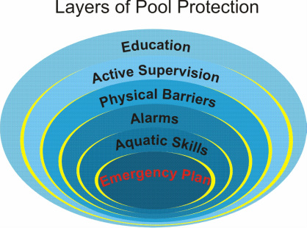
Know the rules, Teach the rules and Follow the rules
Have an Emergency Action Plan: Know who to call and what to do.
Learn CPR
- Remove toys. Don’t leave pool toys in the water. A child may fall into the water while trying to reach for a toy. Anything floating in the water is an invitation drawing children towards the water — an accident waiting to happen. A toy free pool is a safer pool.
- Keep your eyes on your children. Be The Water Watcher. You should be at least one arm length away from your young swimmers.
- Never leave children unsupervised near a pool, spa or hot tub. During social gatherings, adults who know how to swim can take turns being the “Designated Water Watcher.” Don’t rely on air-filled or foam toys, such as water wings, noodles or inner tubes, to keep children safe. This becomes a false sense of security. Practice the Water Watcher Program: a designated Water Watcher takes 15-20 minute shifts of being at the water watching the swimmers. This adult must know how to swim, be alcohol free, never leave the area without a replacement, should know CPR and be watchful. Get a Water Watcher Tag

- Beware of drains. Don’t allow children to play near or sit on pool or hot tub drains. Body parts and hair may become entrapped by the strong suction. Be Compliant. Newer pools have compliant pool drains. https://katchakid.com/have-you-checked-your-pool-drain-cover
- Keep emergency equipment handy. Store a safety ring with a rope and/or a long pole beside the pool.
- “Reach or Throw, Don’t Go.” Tell the struggling swimmer to grab on and pull to safety. Do not go into the water unless a swimmer is submerged at the bottom or cannot grasp the safety equipment. Make sure you always have a phone in the pool area with a safety card that shows 911 emergency numbers in BOLD and the physical address of the home.
Don’t become a statistic: Be Cool Follow the Rules, Be a Water Watcher and Watch the Water.
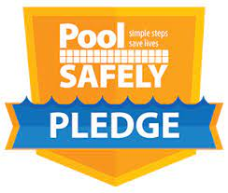
“Swimming is not only a life skill fundamental to a child’s development and an essential safety skill, but learning to swim is a defining experience in a child’s life that creates a sense of pride, self-esteem, accomplishment and lasting memories,”
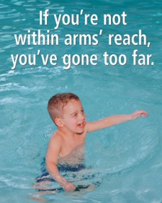
Take the 2020 Pool Safely Pledge:
https://www.poolsafely.gov

Please review the following resources, & let's all try to prevent drowning tragedies from occurring.

.﻿http://www.txdpa.com
http://ndpa.org
http://drowningpreventionfoundation.com
https://www.healthychildren.org
https://www.safekids.org/watersafety
https://www.cdc.gov/safechild/drowning/index.html
http://www.redcross.org/get-help/how-to-prepare-for-emergencies/types-of-emergencies/water-safety

